# Checkpoint Lab-14-2: Docker

# Full Marks: 8

You must submit this lab by Monday 8 November, 8am through Teams-> Assignments->checkpoint 14.2

# Objectives

* Configuring networking inside docker
* Creating a Flask application on Docker
* Deploying a nginx reverse proxy in front of Flask application container
* Deploying nginx-flask through docker compose.

--------------------------------------------------------------------------------------------------

**Today:**

Login to your ubuntu installation (locally, through Azure/AWS instance) where you have installed docker before.

**Task 1: Create a Flask Application Container (2 points)**

1. Build a Flask container using dockerfile
2. Access the webapp through browser

Build a Flask App container and access through browser

--------------------------------------------------------------------------------

* Make a directory flaskapp to serve as a build context for Python/Flask application image
* Copy the lab-4-app folder in the build context from https://github.com/tclark/lab-4-app.git
* Create a docker file in the build context to have the following:

FROM ubuntu:18.04

LABEL updated_on="2021-10-27 09:00"

RUN apt-get update

RUN apt-get -y upgrade

RUN apt-get -y install python3 python3-setuptools python3-pip gunicorn3

RUN update-alternatives --install /usr/bin/python python /usr/bin/python3 10

COPY lab-4-app /flaskapp

WORKDIR /flaskapp

RUN pip3 install -r requirements.txt

EXPOSE 5000

ENTRYPOINT "./startup.sh"

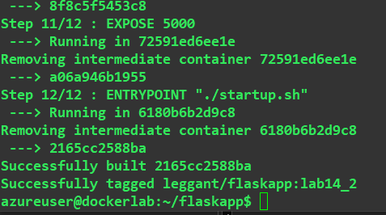

* Build your container image with tag user/flaskapp
* Test it by running:
  + docker run -d –rm –name flaskapp -p 5000:5000 user/flaskapp



Mapped from port 80 to 5000 for access outside

* Verify that it works by checking it with a browser

**Submit:** a) Screenshot of your command executions **(1 point)**

b) Screen shot that verifies that you can connect to your flask app through

your browser? **(1 point)**

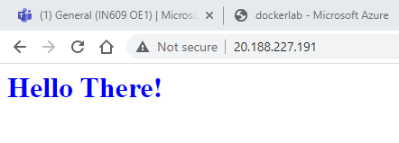

**Task 2: Add a reverse proxy for the Flask app (2 points)**

1. Create a nginx container
2. Create a docker network connecting nginx and the Flask app containers

Create a nginz container:

-------------------------------------------------------------------------------------------

* Set up a build context:

1. place a dockerfile in it:

FROM nginx:1.13

COPY flaskapp.conf /etc/nginx/conf.d/default.conf

EXPOSE 80

1. create the flaskapp.conf file in our build context:

resolver 127.0.0.11 valid=1s;

server {

set $alias "flaskapp";

location / {

proxy_set_header Host $host;

proxy_set_header X-Forwarded-Proto $scheme;

proxy_pass http://$alias:5000;

}

listen 80;

}

* Build this image with tag user/nginx

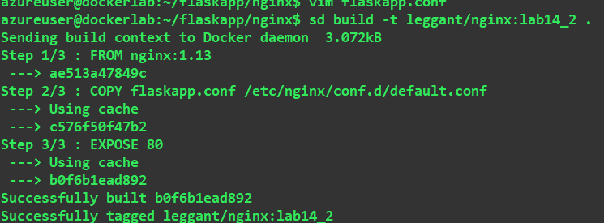

* Create a new bridged network named ‘app’
* Run the above containers to use the new network
  + docker run -d --rm --name flaskapp --network app user/flaskapp
  + docker run -d --rm --name nginx --network app -p 8080:80 user/nginx

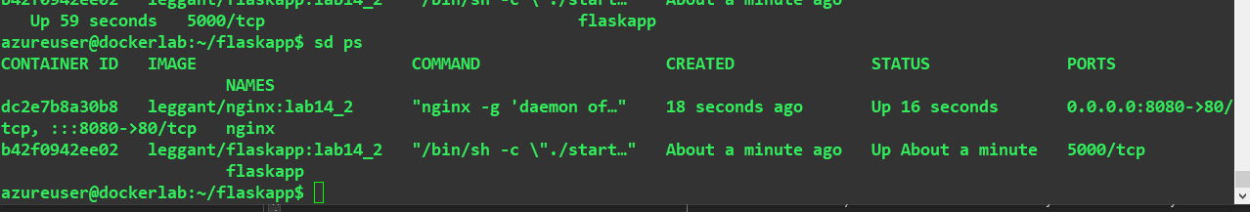

**Submit:** a) Screenshot of command execution and **(1 point)**

1. Screen shot that verifies that you can connect to your flask app through nginx using your browser? **(1 point)**

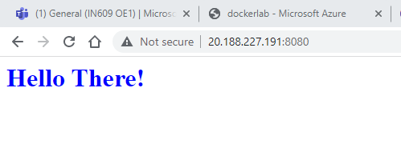

**Task 3. Create a docker-compose file that will save you from using the docker run commands that you have used in Task2 (4 points)**

**Submit:** a. Docker compose file **(2 points)**

b. Screen shot of command execution **(1 point)**

c. Screen shot that verifies that you can connect to your flask app through nginx using your browser? **(1 point)**

